Hyperboloidal Solids of Revolution

Definition
# Source: AI Source: Provided by: [Data Path: Persons Table -> ID Column: 1, Name_En Column: Motasem Essam] -> From: [ChatGPT] on [7/25/2026]
A Hyperboloidal Solid of Revolution is a three-dimensional geometric form generated by rotating a hyperbolic plane region around one of the principal axes of its generating hyperbola.
The resulting surface is a Hyperboloid of Revolution, which can form either a one-sheeted or a two-sheeted hyperboloidal solid, depending on the axis of rotation.
There are two fundamental forms:
- One-Sheeted Hyperboloid: Generated by rotating a hyperbola around its conjugate axis.
- Two-Sheeted Hyperboloid: Generated by rotating a hyperbola around its transverse axis.
Important distinction:
- Rotating a hyperbolic curve generates a hyperboloidal surface.
- Rotating a filled hyperbolic region generates a three-dimensional region associated with that surface. For a one-sheeted hyperboloid, the natural filled cross-sections extend radially outward from the axis; for a two-sheeted hyperboloid, the two components are separate and do not include the central gap.

Geometric Representation
# Source: AI Source: Provided by: [Data Path: Persons Table -> ID Column: 1, Name_En Column: Motasem Essam] -> From: [ChatGPT] on [7/25/2026]
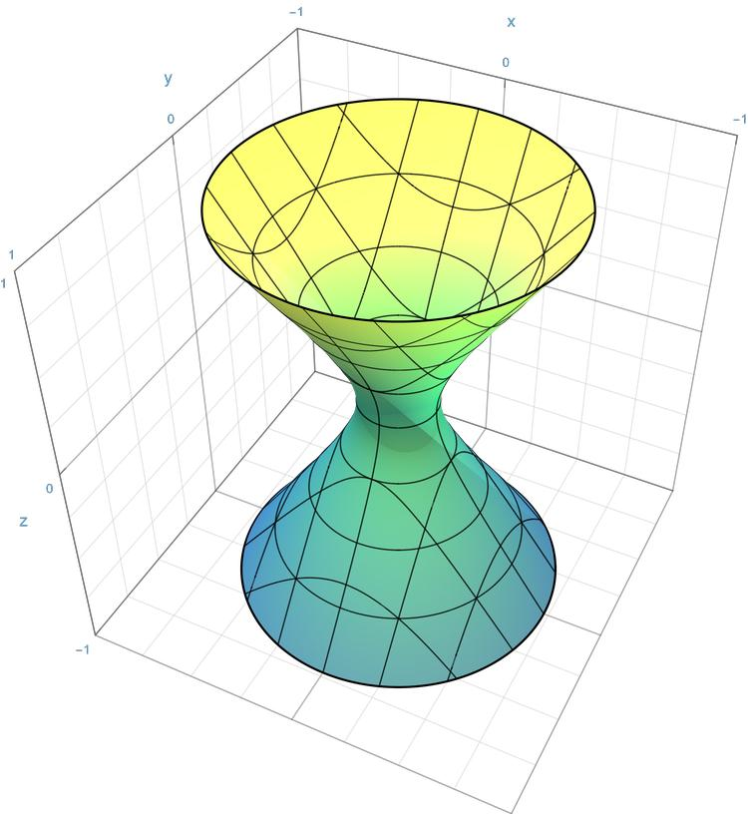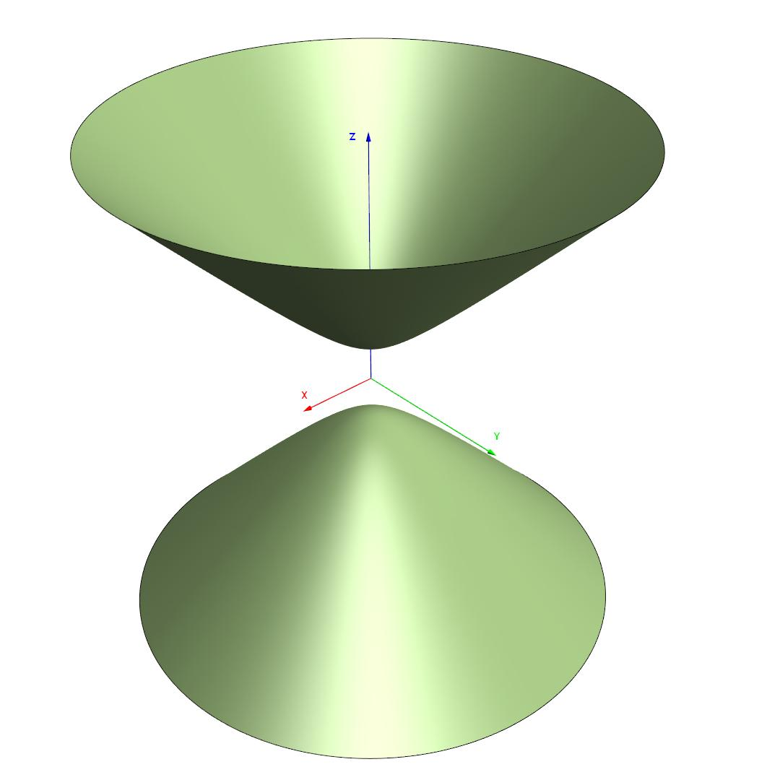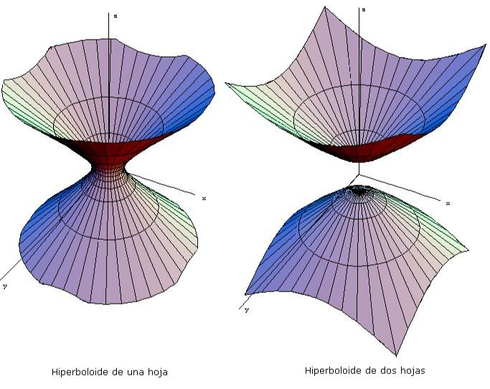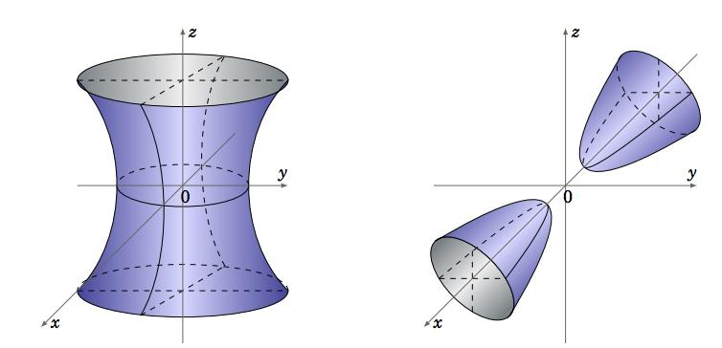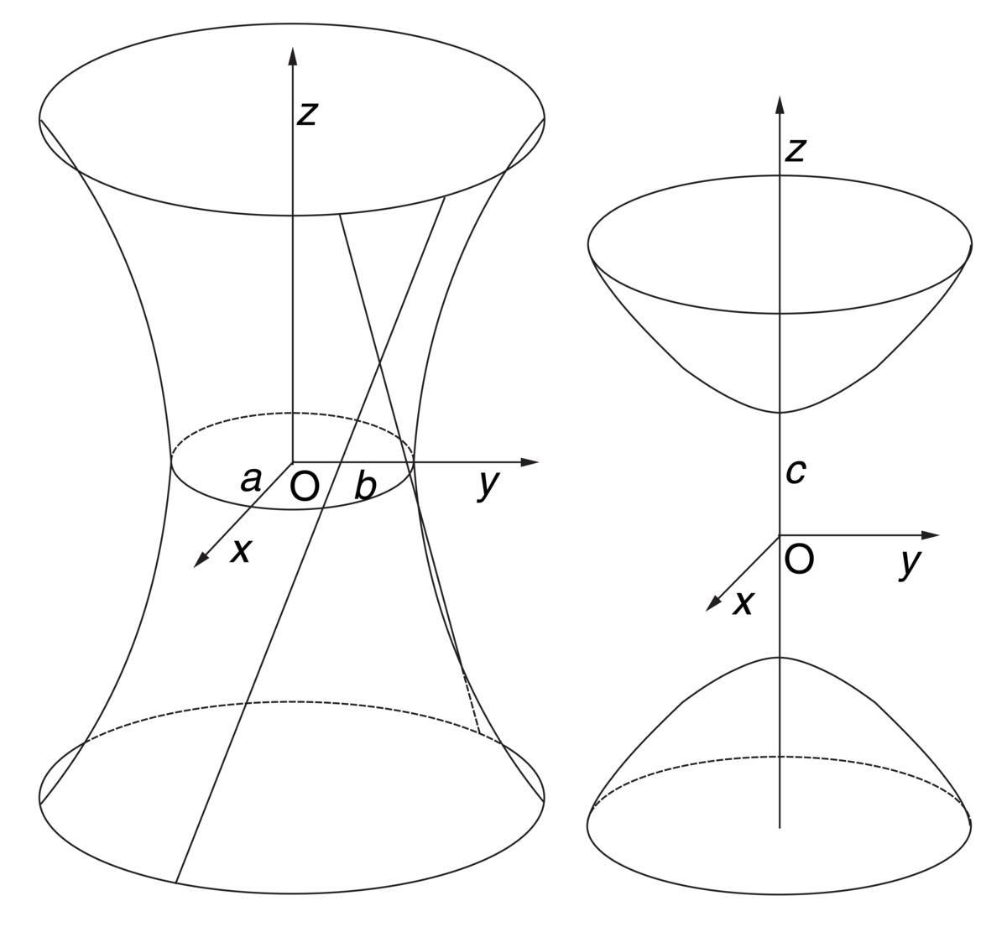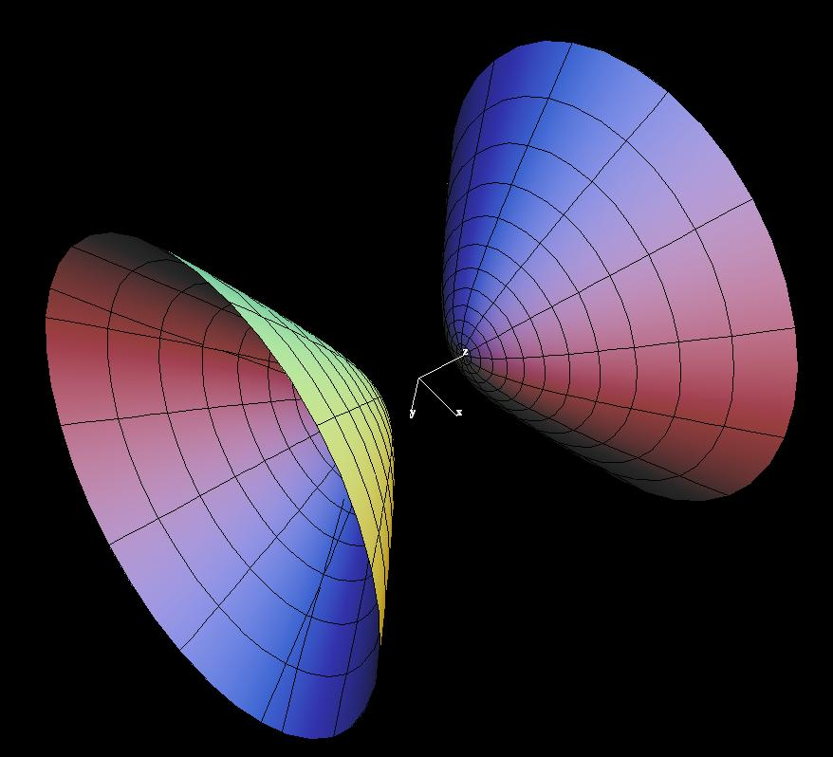

Geometric Structure
# Source: AI Source: Provided by: [Data Path: Persons Table -> ID Column: 1, Name_En Column: Motasem Essam] -> From: [ChatGPT] on [7/25/2026]
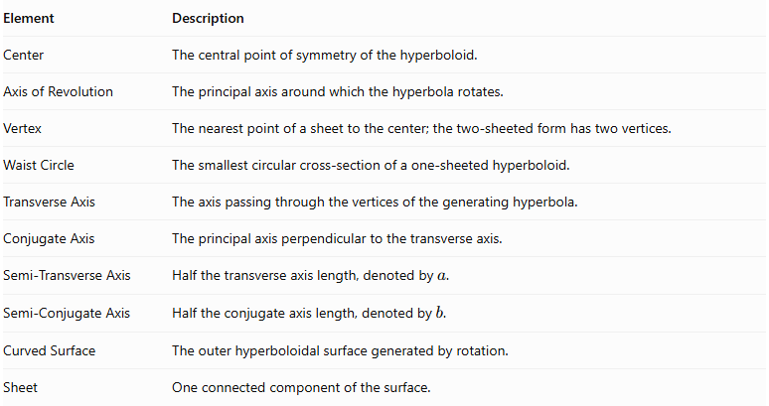
Element | Description
Center | The central point of symmetry of the hyperboloid.
Axis of Revolution | The principal axis around which the hyperbola rotates.
Vertex | The nearest point of a sheet to the center; the two-sheeted form has two vertices.
Waist Circle | The smallest circular cross-section of a one-sheeted hyperboloid.
Transverse Axis | The axis passing through the vertices of the generating hyperbola.
Conjugate Axis | The principal axis perpendicular to the transverse axis.
Semi-Transverse Axis | Half the transverse axis length, denoted by $a$.
Semi-Conjugate Axis | Half the conjugate axis length, denoted by $b$.
Curved Surface | The outer hyperboloidal surface generated by rotation.
Sheet | One connected component of the surface.

Types of Hyperboloidal Solids of Revolution

One-Sheeted Hyperboloid of Revolution
# Source: AI Source: Provided by: [Data Path: Persons Table -> ID Column: 1, Name_En Column: Motasem Essam] -> From: [ChatGPT] on [7/25/2026]
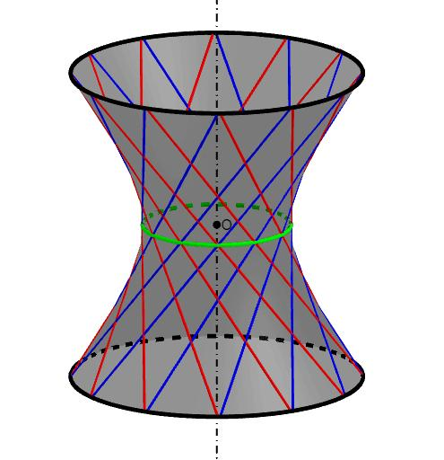
A One-Sheeted Hyperboloid of Revolution is generated by rotating a hyperbola around its conjugate axis (the axis perpendicular to its transverse axis).
Its shape consists of one continuous connected surface that narrows around the middle and expands toward both ends.
Characteristics:
- Has one connected sheet.
- Has a central waist circle.
- Has no vertex on its axis of revolution.
- Its horizontal cross-sections are circles.
- Its axial cross-sections are hyperbolas.
- It is a doubly ruled surface: through each point, two distinct straight lines lie entirely on the surface.
Generating axis: Conjugate axis of the hyperbola.

Two-Sheeted Hyperboloid of Revolution
# Source: AI Source: Provided by: [Data Path: Persons Table -> ID Column: 1, Name_En Column: Motasem Essam] -> From: [ChatGPT] on [7/25/2026]
A Two-Sheeted Hyperboloid of Revolution is generated by rotating a hyperbola around its transverse axis.
Its shape consists of two separate curved sheets positioned on opposite sides of the center.
Characteristics:
- Has two disconnected sheets.
- Has two vertices.
- Has a central gap between the sheets.
- Its cross-sections perpendicular to the axis are circles when they exist.
- Its axial cross-sections are hyperbolas.
- Each sheet expands as its distance from the vertex increases.
Generating axis: Transverse axis of the hyperbola.

Mathematical Representation

One-Sheeted Hyperboloid
# Source: AI Source: Provided by: [Data Path: Persons Table -> ID Column: 1, Name_En Column: Motasem Essam] -> From: [ChatGPT] on [7/25/2026]
With its axis of revolution along the $z$-axis:
$$\boxed{\frac{x^{2}+y^{2}}{a^{2}}-\frac{z^{2}}{c^{2}}=1}$$
Where:
- $a$ = radius of the waist circle.
- $c$ = vertical scale parameter.
- $z$ = distance along the axis of revolution.
The radius of a circular cross-section at height $z$ is:
$$ρ(z)=a\sqrt{1+\frac{z^{2}}{c^{2}}}$$
At the center, $z=0$:
$$ρ(0)=a$$
Therefore, the waist circle has radius $a$.

Two-Sheeted Hyperboloid
# Source: AI Source: Provided by: [Data Path: Persons Table -> ID Column: 1, Name_En Column: Motasem Essam] -> From: [ChatGPT] on [7/25/2026]
With its axis of revolution along the $z$-axis:
$$\boxed{\frac{z^{2}}{c^{2}}-\frac{x^{2}+y^{2}}{a^{2}}=1}$$
Where:
- $a$ = radial scale parameter.
- $c$ = distance from the center to either vertex.
- $z$ = distance along the axis of revolution.
The vertices are located at:
$$(0,0,c), (0,0,-c)$$
The radius of a circular cross-section is:
$$ρ(z)=a\sqrt{\frac{z^{2}}{c^{2}}-1}$$
This expression is real only when:
$$|z|≥c$$
Therefore, there are no real cross-sections inside the central gap.

Mathematical Properties
# Source: AI Source: Provided by: [Data Path: Persons Table -> ID Column: 1, Name_En Column: Motasem Essam] -> From: [ChatGPT] on [7/25/2026]
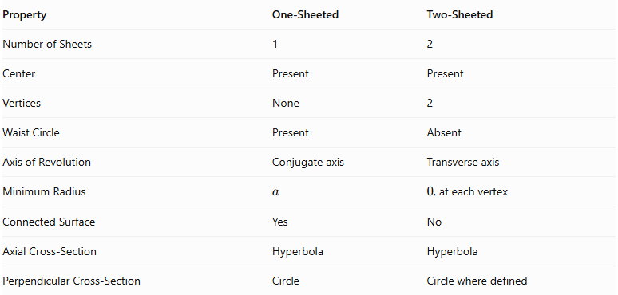
Property | One-Sheeted | Two-Sheeted
Number of Sheets | 1 | 2
Center | Present | Present
Vertices | None | 2
Waist Circle | Present | Absent
Axis of Revolution | Conjugate axis | Transverse axis
Minimum Radius | $$a$$ | $0$, at each vertex
Connected Surface | Yes | No
Axial Cross-Section | Hyperbola | Hyperbola
Perpendicular Cross-Section | Circle | Circle where defined

Eccentricity
# Source: AI Source: Provided by: [Data Path: Persons Table -> ID Column: 1, Name_En Column: Motasem Essam] -> From: [ChatGPT] on [7/25/2026]
For the generating hyperbola:
$$e=\frac{\sqrt{a^{2}+b^{2}}}{a}$$
Where $a$ is the semi-transverse axis and $b$ is the semi-conjugate axis.
For every non-degenerate hyperbola:
$$e>1$$

Volume of a Finite Portion
# Source: AI Source: Provided by: [Data Path: Persons Table -> ID Column: 1, Name_En Column: Motasem Essam] -> From: [ChatGPT] on [7/25/2026]
Hyperboloids extend infinitely, so their complete volumes are infinite. A finite volume must be defined by cutting the solid with one or more planes.
One-sheeted hyperboloid
For the portion between $z=-H/2$ and $z=H/2$:
$$V=πa^{2}H\left(1+\frac{H^{2}}{12c^{2}}\right)$$
Two-sheeted hyperboloid
For both sheets, each truncated between its vertex and a distance $L$ beyond it:
$$V=2πa^{2}\left(\frac{L^{3}}{3c^{2}}+\frac{L^{2}}{c}\right)$$
These formulas describe the volumes bounded by the specified cutting planes and the corresponding hyperboloidal surfaces.

Cross-Sections
# Source: AI Source: Provided by: [Data Path: Persons Table -> ID Column: 1, Name_En Column: Motasem Essam] -> From: [ChatGPT] on [7/25/2026]
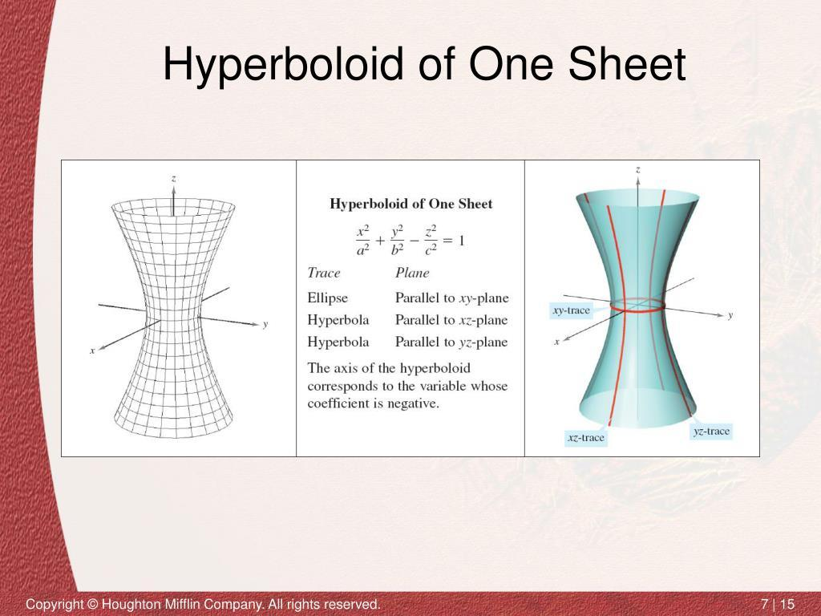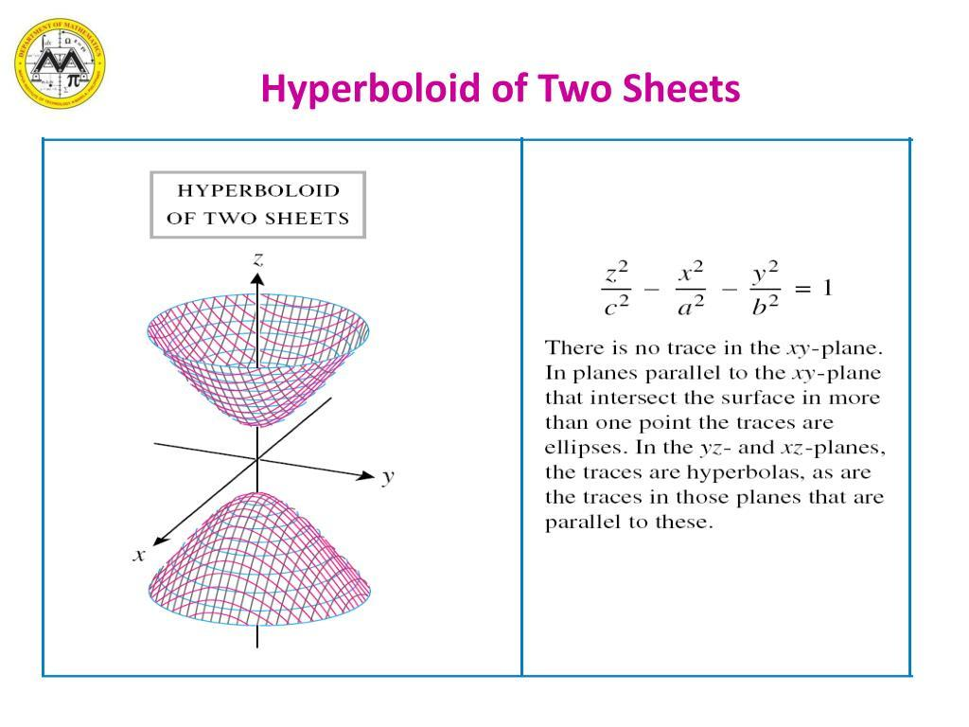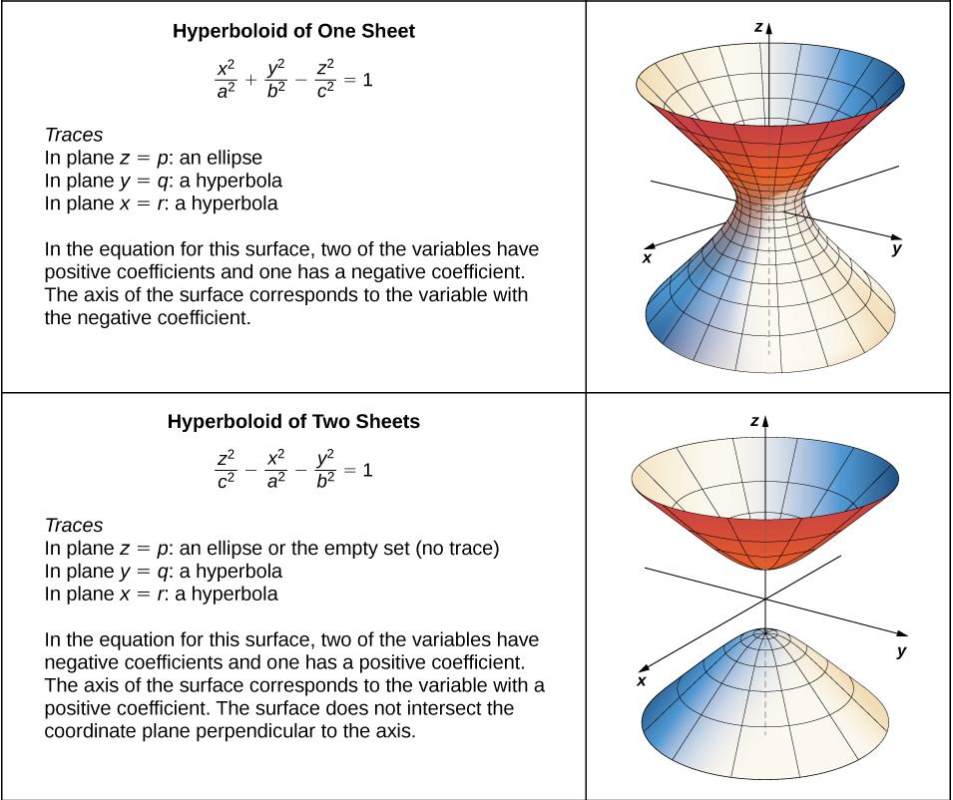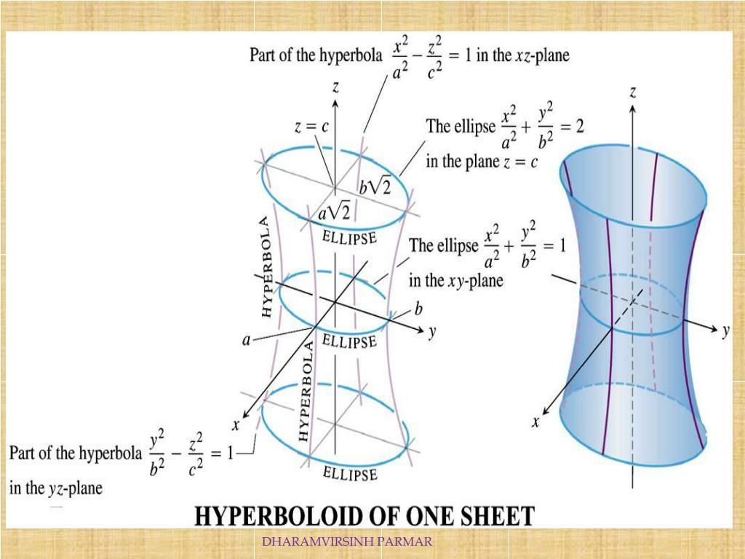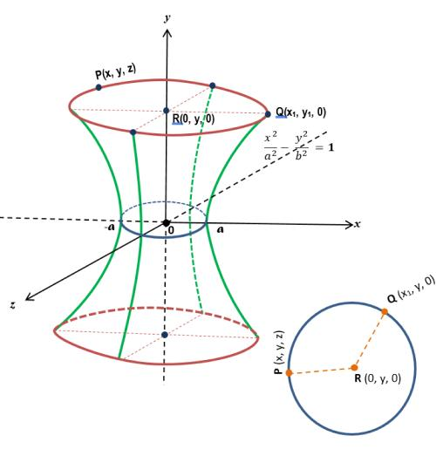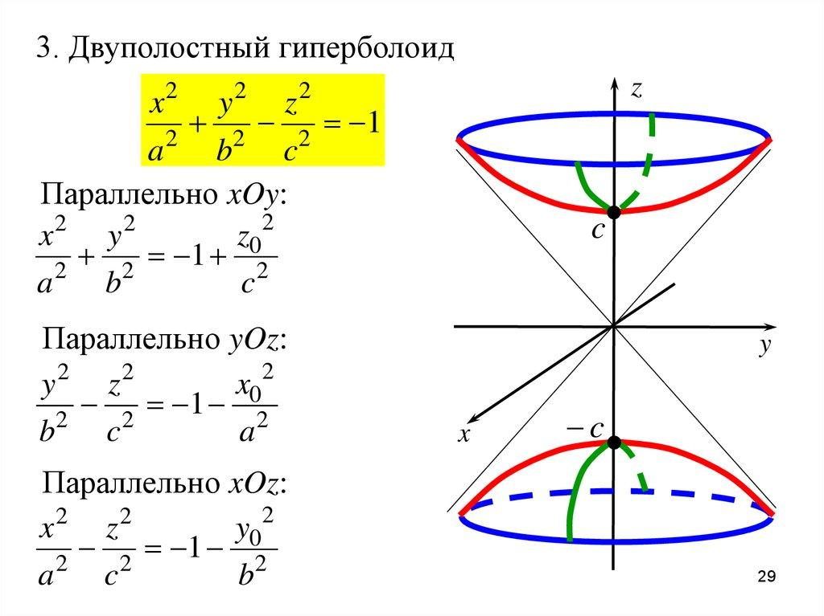

One-Sheeted Hyperboloid
# Source: AI Source: Provided by: [Data Path: Persons Table -> ID Column: 1, Name_En Column: Motasem Essam] -> From: [ChatGPT] on [7/25/2026]
- Axial Cross-Section: A hyperbola.
- Central Cross-Section: A circle with radius $a$.
- Parallel Cross-Sections: Circles whose radii increase as the distance from the center increases.

Two-Sheeted Hyperboloid
# Source: AI Source: Provided by: [Data Path: Persons Table -> ID Column: 1, Name_En Column: Motasem Essam] -> From: [ChatGPT] on [7/25/2026]
- Axial Cross-Section: A hyperbola.
- Vertex Cross-Section: A single point at each vertex.
- Parallel Cross-Sections: Circles that increase in radius as the distance from either vertex increases.
- Central Plane: Does not intersect the surface.

Applications
# Source: AI Source: Provided by: [Data Path: Persons Table -> ID Column: 1, Name_En Column: Motasem Essam] -> From: [ChatGPT] on [7/25/2026]
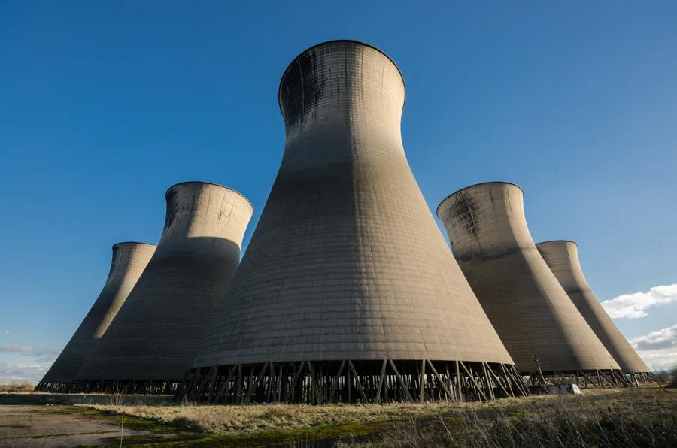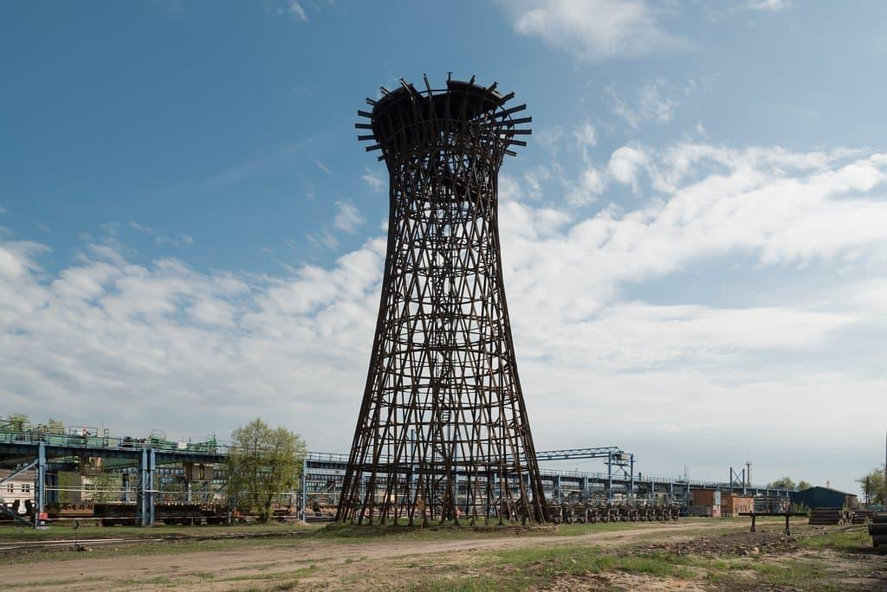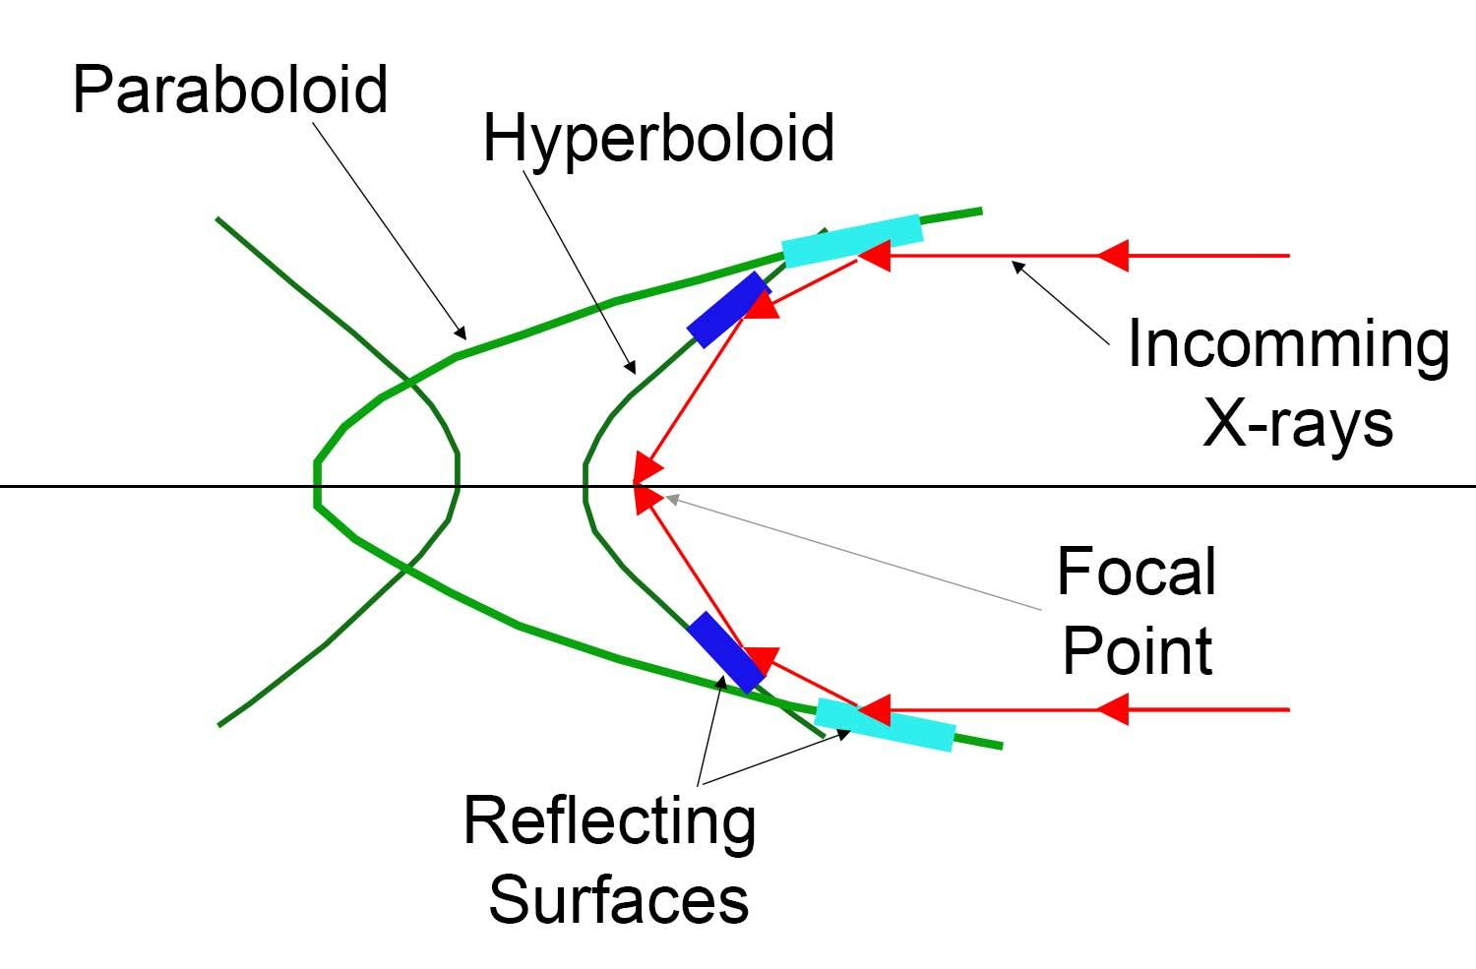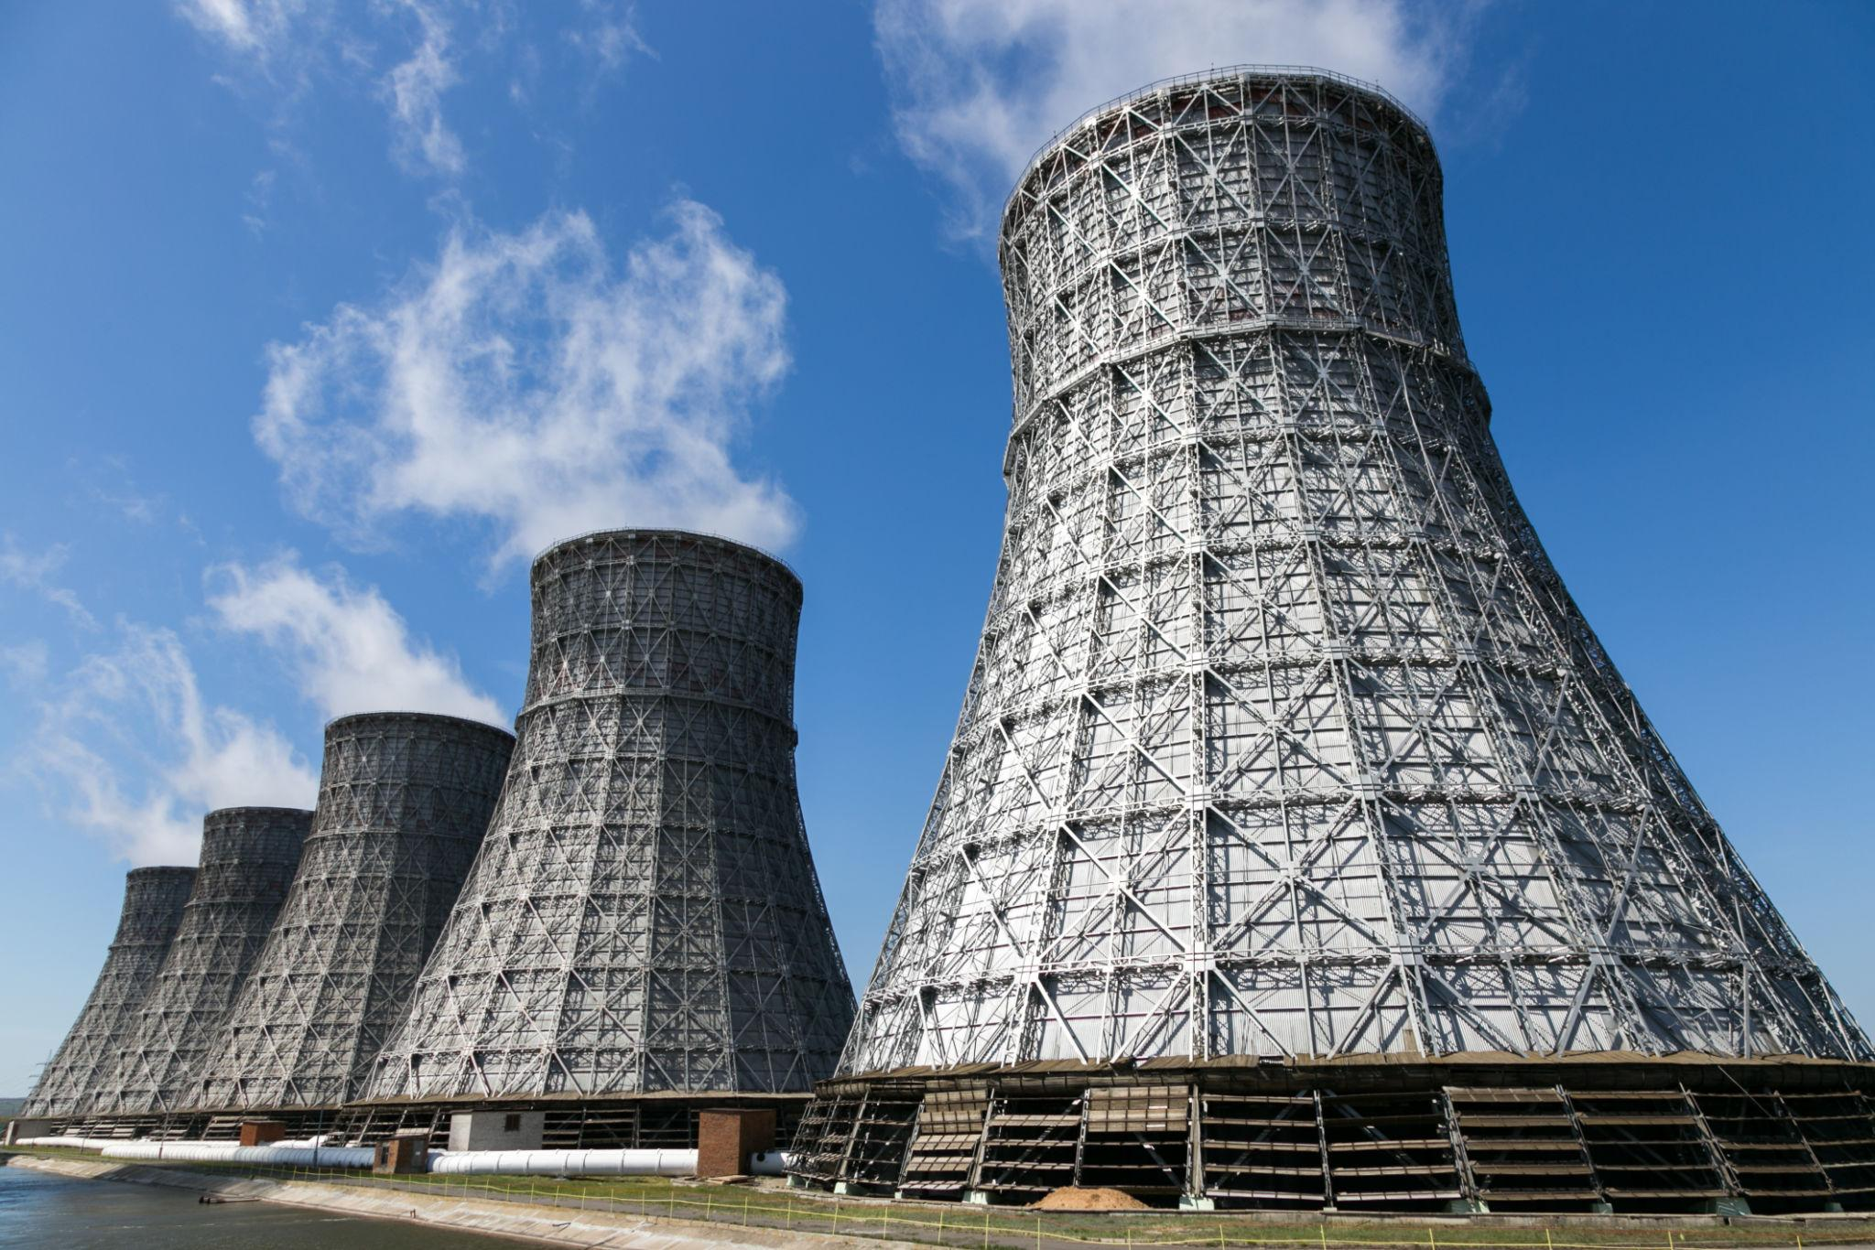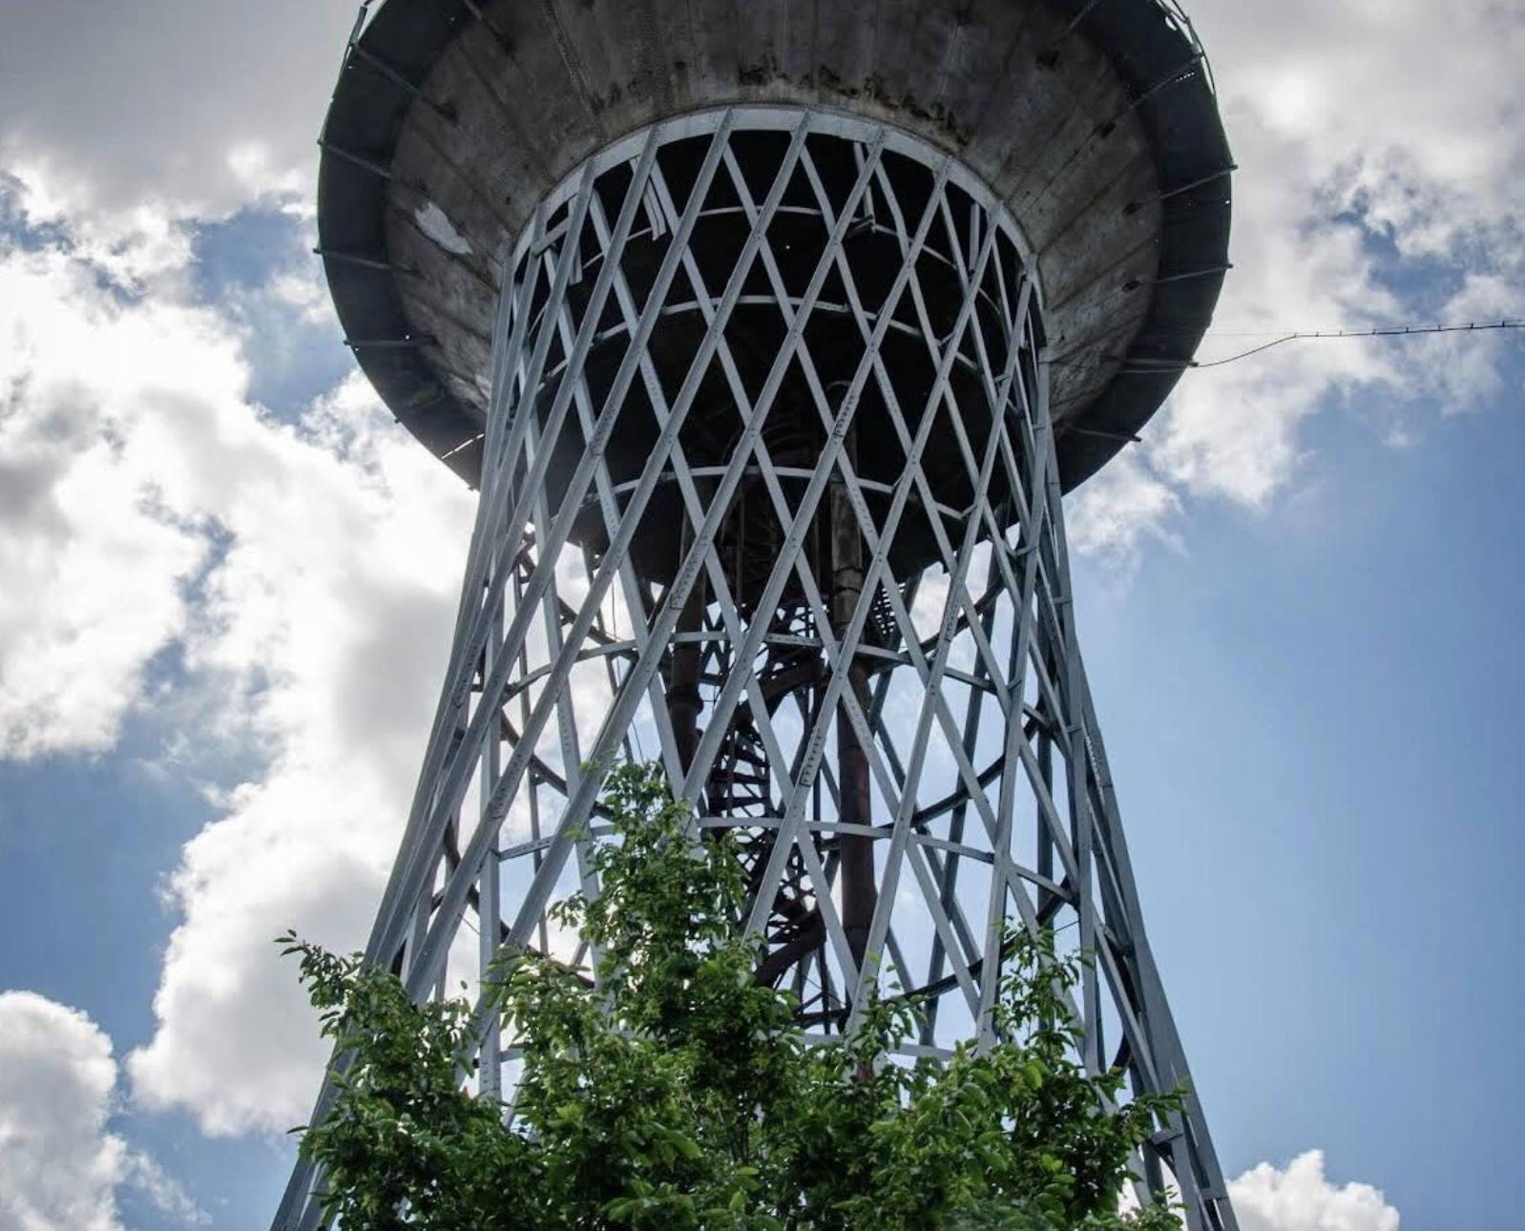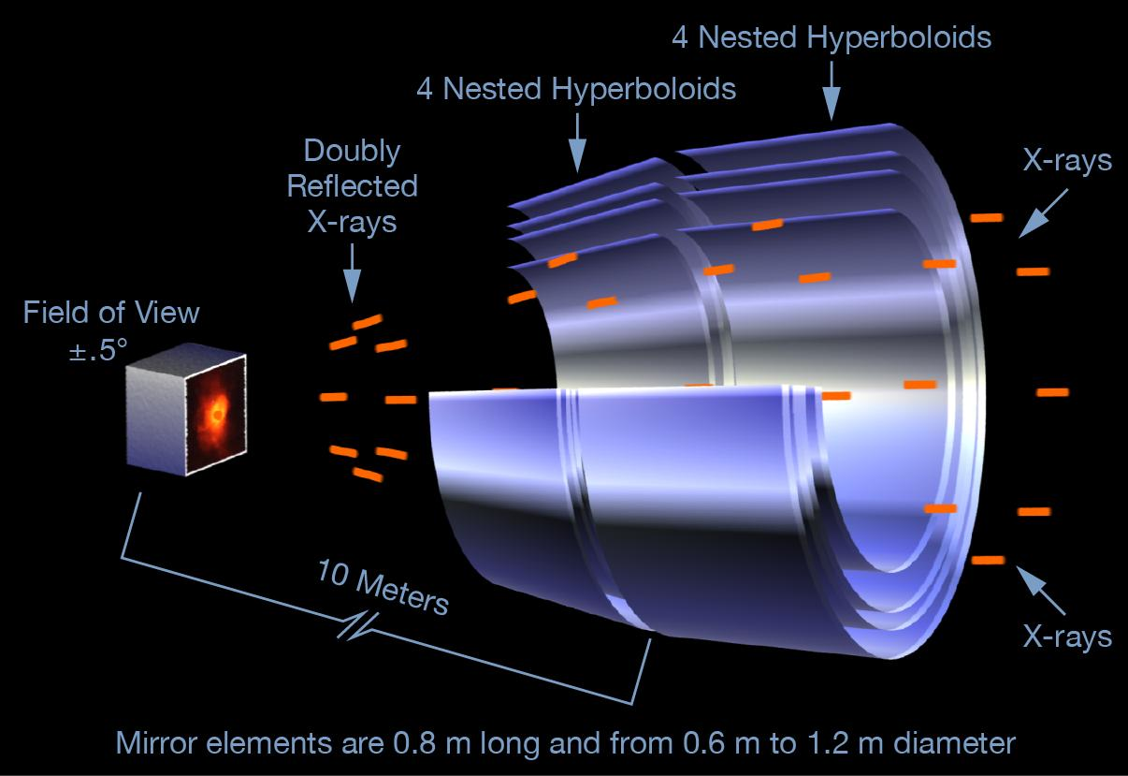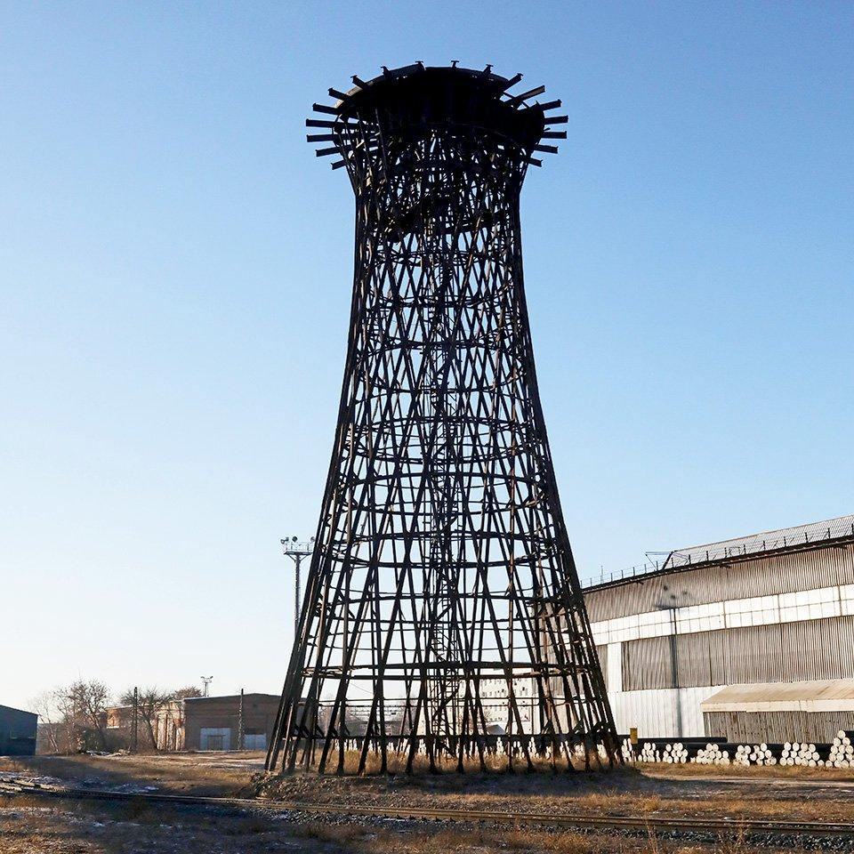
- Cooling Towers: One-sheeted hyperboloidal forms are used in industrial cooling-tower structures.
- Architecture: Hyperboloidal surfaces are used in towers, roofs, and structural designs.
- Structural Engineering: Doubly ruled one-sheeted hyperboloids can be constructed using straight structural members.
- Industrial Structures: Hyperboloidal shapes are used in lightweight frameworks and support structures.
- Mathematics and Geometry: They are studied as examples of quadric surfaces and ruled surfaces.

Comparison with Other Solids of Revolution
# Source: AI Source: Provided by: [Data Path: Persons Table -> ID Column: 1, Name_En Column: Motasem Essam] -> From: [ChatGPT] on [7/25/2026]
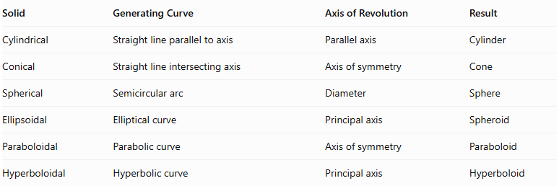
Solid | Generating Curve | Axis of Revolution | Result
Cylindrical | Straight line parallel to axis | Parallel axis | Cylinder
Conical | Straight line intersecting axis | Axis of symmetry | Cone
Spherical | Semicircular arc | Diameter | Sphere
Ellipsoidal | Elliptical curve | Principal axis | Spheroid
Paraboloidal | Parabolic curve | Axis of symmetry | Paraboloid
Hyperboloidal | Hyperbolic curve | Principal axis | Hyperboloid

Main Classification
# Source: AI Source: Provided by: [Data Path: Persons Table -> ID Column: 1, Name_En Column: Motasem Essam] -> From: [ChatGPT] on [7/25/2026]
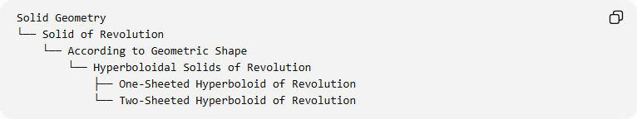
Solid Geometry
└── Solid of Revolution
└── According to Geometric Shape
└── Hyperboloidal Solids of Revolution
├── One-Sheeted Hyperboloid of Revolution
└── Two-Sheeted Hyperboloid of Revolution

Key Points
# Source: AI Source: Provided by: [Data Path: Persons Table -> ID Column: 1, Name_En Column: Motasem Essam] -> From: [ChatGPT] on [7/25/2026]
- Hyperboloidal surfaces are generated by rotating hyperbolic curves around principal axes.
- A one-sheeted hyperboloid is generated around the conjugate axis.
- A two-sheeted hyperboloid is generated around the transverse axis.
- The one-sheeted form is connected and has a waist circle.
- The two-sheeted form has two separate components and two vertices.
- Both forms have circular cross-sections perpendicular to their axes of revolution.
- A one-sheeted hyperboloid is a doubly ruled surface.
- Complete hyperboloids are unbounded; finite solid portions require specified cutting planes.

Conclusion
# Source: AI Source: Provided by: [Data Path: Persons Table -> ID Column: 1, Name_En Column: Motasem Essam] -> From: [ChatGPT] on [7/25/2026]
Hyperboloidal solids of revolution are geometric forms generated by rotating hyperbolic curves around their principal axes. They are classified into one-sheeted and two-sheeted hyperboloids, distinguished by their generating axes, connectedness, and geometric structures. They have important applications in architecture, structural engineering, and mathematical geometry.

